CNMV - TIBER-ES Compliance for Log360
Tagline: Support Spanish financial cyber resilience with threat detection from Log360.

Overview
The CNMV / TIBER-ES (Threat Intelligence-Based Ethical Red Teaming — Spain) Compliance extension for Log360 supports Spanish financial market participants and critical service providers in preparing for and measuring the effectiveness of TIBER-ES threat-led penetration testing exercises coordinated by the Banco de España and CNMV.
Log360 provides the security monitoring and detection capabilities needed to assess blue team performance during adversarial simulations, correlating log data to surface attack paths and detection gaps. Security teams can evaluate detection coverage and document blue team responses for supervisory review.

Key Features
- Generate reports documenting security event detection, alert timelines, and blue team response activities during TIBER-ES exercises.
- Monitor simulated attacker activity across Active Directory, endpoints, cloud environments, and network infrastructure in real time.
- Provide detailed forensic analysis and incident investigation capabilities to support blue team post-exercise reviews, including timeline reconstruction and evidence preservation.
- Export TIBER-ES exercise documentation in PDF and CSV formats for Banco de España and CNMV after-action reviews.



Screenshots
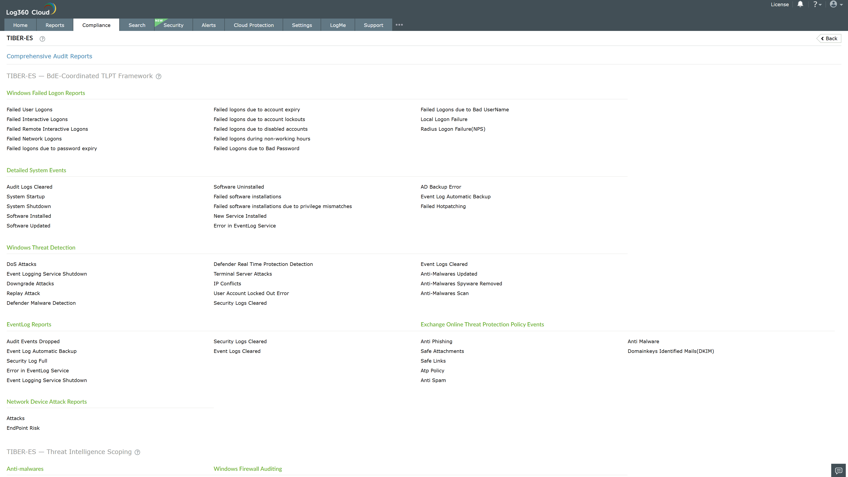
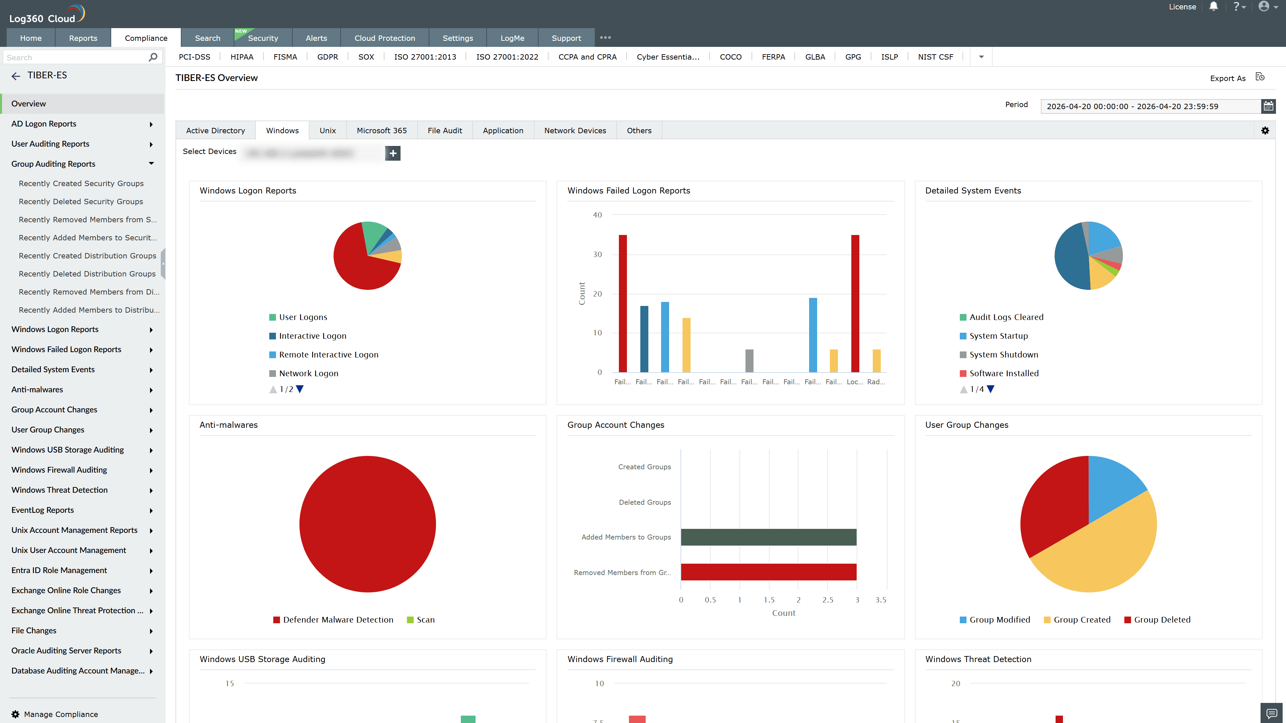
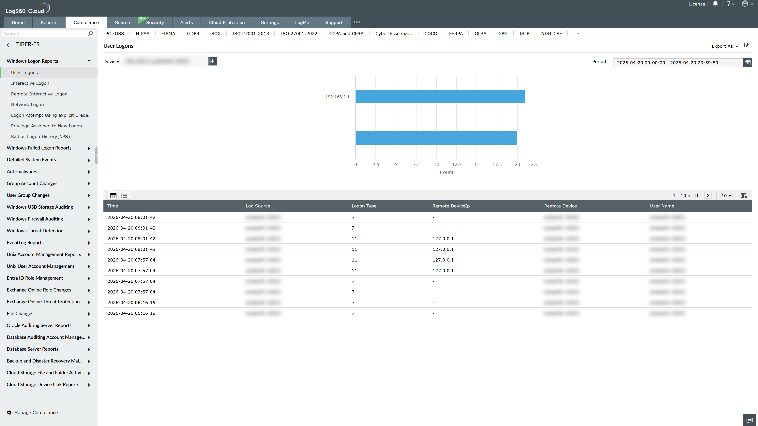
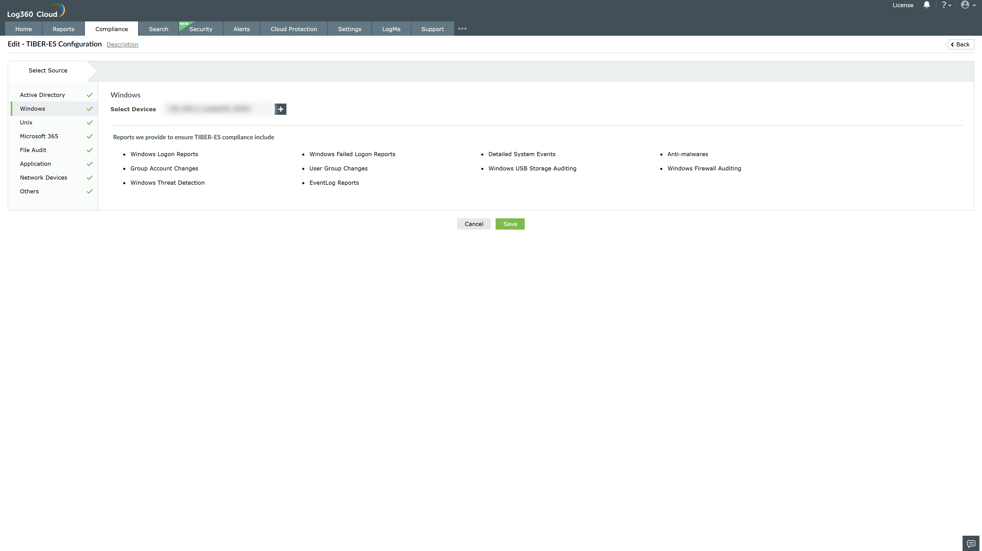
Valid Submission : Yes
Supported Editions : Free, Basic, Standard, Professional, MSSP
Help Document : https://www.manageengine.com/log-management/help/integrations/compliance-extensions.html
Help Video : Not provided
Tags : Log360, Compliance, Privacy monitoring, Data privacy, Regulatory compliance
Supported DCs : US, IN, JP, CA, AU, UK and EU
Privacy Policy:
Terms of Service:
Release Notes:
Predefined reports for the CNMV / TIBER-ES Compliance

